Object Oriented Programming

Lab Report

Name - Naman Dixit

Sap ID - 500125539

Batch - 7 Data Science

**Assignment 1**

TITLE: Introduction to Java Environment

1. Explore and understand the role of JDK, JRE and JVM.

2. Install the latest available JDK and verify the Java Environment.

3. Create a Sample Hello World Program using a simple text editor (e.g. Notepad) and show the steps to compile and execute the program using command prompt.

4. Display your name and complete address in different lines.

Additional Question:-

5. Design a visually appealing grade sheet that displays the Name, Roll Number, SAP ID, and Result. Use escape sequences and special characters like '*' to enhance its presentation. [No need to take any input from User].

Answer-

#4

public class Address{

public static void main(String args[]){

System.out.println("Naman Dixit");

System.out.println("51, Lane number 2, Bank Colony, Ajabpur Kalan, Mothrowala Road, Dehradun, Uttarakhand.");

}

}

Output -

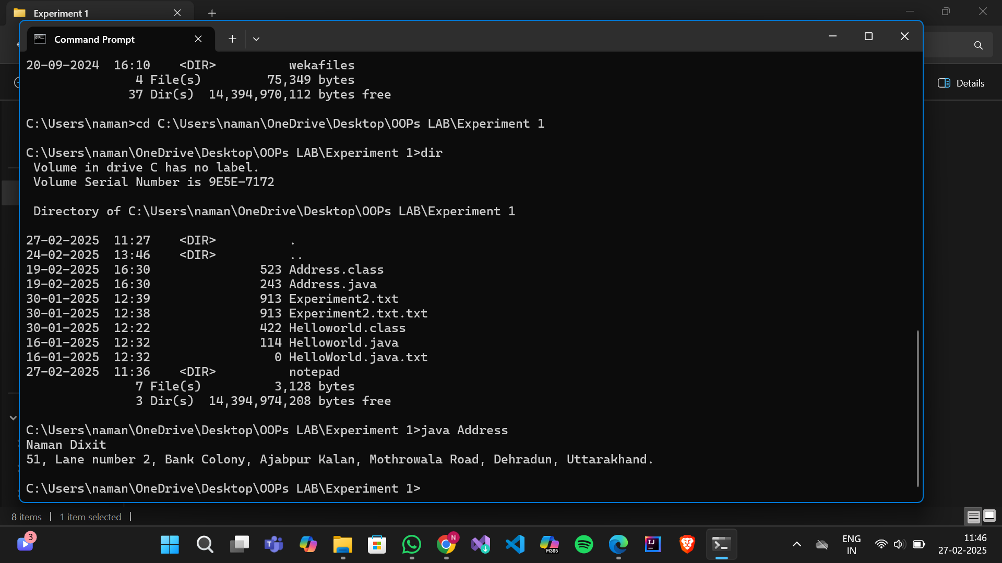

#5

public class Experiment2 {

public static void main(String[] args) {

// Defining student details

String name = "Naman Dixit";

String rollNumber = "R2142231696";

String sapID = "5000125539";

String result = "Pass";

// Printing the gradesheet with formatting

System.out.println("*************************************");

System.out.println("* STUDENT GRADESHEET *");

System.out.println("*************************************");

System.out.println("* Name : " + name + " *");

System.out.println("* Roll No. : " + rollNumber + " *");

System.out.println("* SAP ID : " + sapID + " *");

System.out.println("* Result : " + result + " *");

System.out.println("*************************************");

}

}

#Output

*************************************

* STUDENT GRADESHEET *

*************************************

* Name : Naman Dixit *

* Roll No. : R2142231696 *

* SAP ID : 5000125539 *

* Result : Pass *

*************************************

### **EXPERIMENT – 2**

**TITLE:** Basic Java Programming

1. Write a program to find the area of a triangle.
2. Write a program to find simple interest.
3. Write a program to implement a command-line calculator. (Perform addition, subtraction, and multiplication in the same program for two numbers.)
4. Write a Java program to check whether a given number is positive, negative, or zero using an **if-else** statement.
5. Create a program that accepts three integers and determines the greatest among them using **nested if-else** statements.
6. Create a program that accepts a number (1–7) and displays the corresponding **day of the week** using a **switch** statement.

#1

import java.util.Scanner;

public class TriangleArea1 {

public static void main(String[] args) {

Scanner scanner = new Scanner(System.in);

// Input base and height

System.out.print("Enter base: ");

double base = scanner.nextDouble();

System.out.print("Enter height: ");

double height = scanner.nextDouble();

// Calculate area

double area = 0.5 * base * height;

System.out.println("Area of the triangle: " + area);

scanner.close();

}

}

Output -

Enter base: 5

Enter height: 3

Area of the triangle: 7.5

#2

import java.util.Scanner;

public class SimpleInterest {

public static void main(String args[]) {

Scanner sc = new Scanner(System.in);

System.out.println("Enter rate:");

double rate = sc.nextDouble();

System.out.println("Enter principal amount:");

double Prin = sc.nextDouble();

System.out.println("Enter Time:");

int T = sc.nextInt();

double SI = (Prin * rate * T) / 100;

System.out.println("Simple interest= " + SI);

}

}

Output-

Enter rate:

12

Enter principal amount:

100

Enter Time:

1

Simple interest= 12.0

#3

public class Calculator {

public static void main(String[] args) {

if (args.length < 3) {

System.out.println("Usage: java Calculator <num1> <operator> <num2>");

return;

}

int num1 = Integer.parseInt(args[0]);

int num2 = Integer.parseInt(args[2]);

char operator = args[1].charAt(0);

int result = 0;

switch (operator) {

case '+':

result = num1 + num2;

break;

case '-':

result = num1 - num2;

break;

case '*':

result = num1 * num2;

break;

case '/':

if (num2 != 0) {

result = num1 / num2;

} else {

System.out.println("Cannot divide by zero!");

return;

}

break;

default:

System.out.println("Invalid operator!");

return;

}

System.out.println("Result: " + result);

}

}

Output-

Usage: java Calculator <num1> <operator> <num2>

PS C:\Users\naman\OneDrive\Desktop\OOPs LAB\Experiment 2> 2 + 4

6

#4

import java.util.Scanner;

public class NumberUserInput {

public static void main(String[] args) {

Scanner scanner = new Scanner(System.in);

// Ask user to enter a number

System.out.print("Enter a number: ");

double number = scanner.nextDouble();

if (number > 0) {

System.out.println(number + " is a positive number.");

} else if (number < 0) {

System.out.println(number + " is a negative number.");

} else {

System.out.println("The number is zero.");

}

scanner.close();

}

}

Output- Enter a number: 3

3.0 is a positive number.

#5

import java.util.Scanner;

public class GreatestOfThree {

public static void main(String[] args) {

Scanner sc = new Scanner(System.in);

System.out.print("Enter first number: ");

int a = sc.nextInt();

System.out.print("Enter second number: ");

int b = sc.nextInt();

System.out.print("Enter third number: ");

int c = sc.nextInt();

int greatest = (a > b) ? ((a > c) ? a : c) : ((b > c) ? b : c);

System.out.println("Greatest number: " + greatest);

sc.close();

}

}

Output -

Enter first number: 3

Enter second number: 6

Enter third number: 15

Greatest number: 15

#6

import java.util.Scanner;

public class DayOfWeek {

public static void main(String[] args) {

Scanner sc = new Scanner(System.in);

System.out.print("Enter a number (1-7): ");

int day = sc.nextInt();

String dayName;

switch (day) {

case 1:

dayName = "Monday";

break;

case 2:

dayName = "Tuesday";

break;

case 3:

dayName = "Wednesday";

break;

case 4:

dayName = "Thursday";

break;

case 5:

dayName = "Friday";

break;

case 6:

dayName = "Saturday";

break;

case 7:

dayName = "Sunday";

break;

default:

dayName = "Invalid input! Enter a number between 1 and 7.";

}

System.out.println("Day: " + dayName);

sc.close();

}

}

Output-

Enter a number (1-7): 45

Day: Invalid input! Enter a number between 1 and 7.

'C:\Users\naman\AppData\Roaming\Code\User\workspaceStorage\2742f3bf7cb2bd81343d1a0e9a726136\redhat.java\jdt_ws\Experiment 2_3b404ad7\bin' 'DayOfWeek'

Enter a number (1-7): 4

Day: Thursday

**EXPERIMENT – 3** **TITLE:** Basic Java Programming (Loops & Arrays)

* Write a program to calculate the sum of all integers between 10 and 950 that are divisible by both 6 and 9.
* Write a Java program that takes an integer as input and calculates the sum of its digits using a while loop.
* Write a Java program that prints the first N terms of the Fibonacci series using a loop.
* Write a Java program to count and display the total number of prime numbers between 1 and 1000.
* Write a Java program that counts how many times a given number appears in an array.  
   **Input:** arr = [2, 3, 2, 5, 2, 6], target = 2  
   **Output:** 3
* Write a Java program to find the second largest element in an integer array without sorting the array.
* Write a program to print the following pattern using a loop:

?

# # #

? ? ? ? ?

# # # # # # #

? ? ? ? ? ? ? ? ?

#1

class Lab4 {

public static void main(String args[]) {

int sum = 0;

int s = 10;

int e = 950;

for (int i = s; i < e; i++) {

if ((i % 6 == 0) && (i % 9 == 0)) {

sum += i;

}

}

System.out.println("Sum=" + sum);

}

}

Output-

Sum=24804

PS C:\Users\naman\OneDrive\Desktop\OOPs LAB\Lab 3>

#2

import java.util.Scanner;

public class SumOfDigits {

public static void main(String[] args) {

Scanner scanner = new Scanner(System.in);

// Taking input from the user

System.out.print("Enter an integer: ");

int number = scanner.nextInt();

int sum = 0;

int temp = Math.abs(number); // Using absolute value to handle negative numbers

// Using while loop to calculate the sum of digits

while (temp > 0) {

sum += temp % 10; // Extract the last digit and add to sum

temp /= 10; // Remove the last digit

}

// Display the result

System.out.println("Sum of digits: " + sum);

scanner.close();

}

}

Output-

Enter an integer: 245

Sum of digits: 11

PS C:\Users\naman\OneDrive\Desktop\OOPs LAB\Lab 3>

#3

import java.util.Scanner;

public class FibonacciSeries {

public static void main(String[] args) {

Scanner scanner = new Scanner(System.in);

System.out.print("Enter number of terms: ");

int n = scanner.nextInt();

int first = 0, second = 1;

System.out.print("Fibonacci Series: ");

for (int i = 0; i < n; i++) {

System.out.print(first + " ");

int next = first + second;

first = second;

second = next;

}

scanner.close();

}

}

Output-

Enter number of terms: 23

Fibonacci Series: 0 1 1 2 3 5 8 13 21 34 55 89 144 233 377 610 987 1597 2584 4181 6765 10946 17711

PS C:\Users\naman\OneDrive\Desktop\OOPs LAB\Lab 3>

#4

public class PrimeNumbers {

public static void main(String[] args) {

int count = 0;

for (int i = 2; i <= 1000; i++) {

if (isPrime(i)) {

count++;

}

}

System.out.println("Total prime numbers between 1 and 1000: " + count);

}

public static boolean isPrime(int num) {

if (num < 2) return false;

for (int i = 2; i <= Math.sqrt(num); i++) {

if (num % i == 0) return false;

}

return true;

}

}

Output- Total prime numbers between 1 and 1000: 168

PS C:\Users\naman\OneDrive\Desktop\OOPs LAB\Lab 3>

#5

import java.util.Scanner;

public class CountOccurrences {

public static void main(String[] args) {

Scanner scanner = new Scanner(System.in);

System.out.print("Enter array size: ");

int n = scanner.nextInt();

int[] arr = new int[n];

System.out.println("Enter array elements:");

for (int i = 0; i < n; i++) {

arr[i] = scanner.nextInt();

}

System.out.print("Enter target number: ");

int target = scanner.nextInt();

int count = 0;

for (int num : arr) {

if (num == target) {

count++;

}

}

System.out.println("Occurrences of " + target + ": " + count);

scanner.close();

}

}

Output- Enter array size: 5

Enter array elements:

11 14

12

15

1616

Enter target number: 12

Occurrences of 12: 1

PS C:\Users\naman\OneDrive\Desktop\OOPs LAB\Lab 3>

#6

import java.util.Scanner;

public class SecondLargest {

public static void main(String[] args) {

Scanner scanner = new Scanner(System.in);

System.out.print("Enter array size: ");

int n = scanner.nextInt();

int[] arr = new int[n];

System.out.println("Enter array elements:");

for (int i = 0; i < n; i++) {

arr[i] = scanner.nextInt();

}

int largest = Integer.MIN_VALUE, secondLargest = Integer.MIN_VALUE;

for (int num : arr) {

if (num > largest) {

secondLargest = largest;

largest = num;

} else if (num > secondLargest && num != largest) {

secondLargest = num;

}

}

if (secondLargest == Integer.MIN_VALUE) {

System.out.println("No second largest element found.");

} else {

System.out.println("Second largest element: " + secondLargest);

}

scanner.close();

}

}

Output-

Enter array size: 6

Enter array elements:

1

1

23

45

67

78

Second largest element: 67

PS C:\Users\naman\OneDrive\Desktop\OOPs LAB\Lab 3>

#7

import java.util.Scanner;

public class PatternPrinting {

public static void main(String[] args) {

Scanner scanner = new Scanner(System.in);

System.out.print("Enter number of rows: ");

int rows = scanner.nextInt();

for (int i = 1; i <= rows; i++) {

if (i % 2 == 1) {

for (int j = 0; j < (2 * i - 1); j++) {

System.out.print("? ");

}

} else {

for (int j = 0; j < (2 * i - 1); j++) {

System.out.print("# ");

}

}

System.out.println();

}

scanner.close();

}

}

Output-

Enter number of rows: 4

?

# # #

? ? ? ? ?

# # # # # # #

PS C:\Users\naman\OneDrive\Desktop\OOPs LAB\Lab 3>

**Experiment 4**

1. Create a Student class with attributes for name and age. Implement a default constructor to assign default values and a parameterized constructor to initialize the attributes with user-defined values. Create objects using both constructors and display their details.
2. Create a **BankAccount** class with a **private variable** balance to store the account balance. Implement a **public method** deposit(double amount) to add funds, a **protected method** withdraw(double amount) to deduct funds, and a **default-access method** checkBalance() to display the current balance. Create an object of the class and demonstrate which methods and variables can be accessed both inside and outside the class.
3. Create a **Calculator** class that contains a method add() to perform addition. Overload the add() method to handle different types and numbers of parameters, such as adding **two integers**, **two doubles**, and **three integers**. Create an object of the class and demonstrate all method variations.
4. Create a **Student** class that has a **static variable** universityName and a **non-static variable** studentName. Include a **static method** to display the university name. Then, create multiple student objects to demonstrate how the **static variable** is shared among all instances, while the **non-static variable** holds unique values for each object.
5. A student is developing a **course registration system** that allows students to enroll in courses. Each course has a **course name** and a **course code**. Implement a **Course** class with appropriate attributes and use the "this" keyword to differentiate between **class attributes** and **constructor parameters** during initialization. Create an object of the **Course** class and display the course details. **[Keep the variable name of formal arguments in the constructor and instance variables the same.]**

#1.

class Student {

String name;

int age;

// Default constructor with default values

public Student() {

this.name = "Unknown";

this.age = 18;

}

// Parameterized constructor to initialize user-defined values

public Student(String name, int age) {

this.name = name;

this.age = age;

}

// Method to display student details

public void display() {

System.out.println("Student Name: " + name);

System.out.println("Student Age: " + age);

System.out.println();

}

public static void main(String[] args) {

// Creating an object using the default constructor

Student student1 = new Student();

// Creating an object using the parameterized constructor

Student student2 = new Student("Alice", 20);

// Displaying details of both students

System.out.println("Details of Student 1:");

student1.display();

System.out.println("Details of Student 2:");

student2.display();

}

}

Output-

Details of Student 1:

Student Name: Unknown

Student Age: 18

Details of Student 2:

Student Name: Naman Dixit

Student Age: 20

#2.

import java.util.Scanner;

class BankAccount {

private double balance;

BankAccount(double balance) {

this.balance = balance;

}

public void deposit(double amount) {

balance += amount;

System.out.println("Deposited: " + amount);

}

protected void withdraw(double amount) {

if (amount <= balance) {

balance -= amount;

System.out.println("Withdrawn: " + amount);

} else {

System.out.println("Insufficient balance!");

}

}

void checkBalance() {

System.out.println("Current Balance: " + balance);

}

public static void main(String[] args) {

Scanner sc = new Scanner(System.in);

System.out.print("Enter initial balance: ");

double initialBalance = sc.nextDouble();

BankAccount account = new BankAccount(initialBalance);

System.out.print("Enter amount to deposit: ");

double depositAmount = sc.nextDouble();

account.deposit(depositAmount);

System.out.print("Enter amount to withdraw: ");

double withdrawAmount = sc.nextDouble();

account.withdraw(withdrawAmount);

account.checkBalance();

sc.close();

}

}

Output:-

Enter initial balance: 500

Enter amount to deposit: 10000

Deposited: 10000.0

Enter amount to withdraw: 400

Withdrawn: 400.0

Current Balance: 10100.0

#3.

import java.util.Scanner;

class Calculator {

int add(int a, int b) {

return a + b;

}

double add(double a, double b) {

return a + b;

}

int add(int a, int b, int c) {

return a + b + c;

}

public static void main(String[] args) {

Scanner sc = new Scanner(System.in);

Calculator calc = new Calculator();

System.out.print("Enter two integers: ");

int int1 = sc.nextInt();

int int2 = sc.nextInt();

System.out.println("Sum of two integers: " + calc.add(int1, int2));

System.out.print("Enter two decimal numbers: ");

double double1 = sc.nextDouble();

double double2 = sc.nextDouble();

System.out.println("Sum of two doubles: " + calc.add(double1, double2));

System.out.print("Enter three integers: ");

int num1 = sc.nextInt();

int num2 = sc.nextInt();

int num3 = sc.nextInt();

System.out.println("Sum of three integers: " + calc.add(num1, num2, num3));

sc.close();

}

}

Output-

Enter two integers: 30

34

Sum of two integers: 64

Enter two decimal numbers: 2.0

0.55

Sum of two doubles: 2.55

Enter three integers: 1

1

1

Sum of three integers: 3

#4.

import java.util.Scanner;

class Student {

static String universityName = "UPES"; // Shared among all instances

String studentName; // Unique for each object

Student(String studentName) {

this.studentName = studentName;

}

static void displayUniversityName() {

System.out.println("University Name:" + universityName);

}

void displayStudentDetails() {

System.out.println("Student Name:" + studentName);

}

public static void main(String[] args) {

Scanner sc = new Scanner(System.in);

displayUniversityName();

System.out.print("Enter student 1 name:" );

String student1Name = sc.nextLine();

System.out.print("Enter student 2 name:" );

String student2Name = sc.nextLine();

Student s1 = new Student(student1Name);

Student s2 = new Student(student2Name);

s1.displayStudentDetails();

s2.displayStudentDetails();

sc.close();

}

}

Output-

University Name:UPES

Enter student 1 name:Naman Dixit

Enter student 2 name:Vivek dixit

Student Name:Naman Dixit

Student Name:Vivek dixit

#5.

import java.util.Scanner;

class Course {

String courseName;

String courseCode;

Course(String courseName, String courseCode) {

this.courseName = courseName;

this.courseCode = courseCode;

}

void displayCourseDetails() {

System.out.println("Course Name: " + courseName);

System.out.println("Course Code: " + courseCode);

}

public static void main(String[] args) {

Scanner sc = new Scanner(System.in);

System.out.print("Enter course name: ");

String name = sc.nextLine();

System.out.print("Enter course code: ");

String code = sc.nextLine();

Course course = new Course(name, code);

course.displayCourseDetails();

sc.close();

}

}

Output-

Enter course name: Digital Electronics

Enter course code: Cseg205224

Course Name: Digital Electronics

Course Code: Cseg205224

### **EXPERIMENT – 5**

#### **TITLE: Inheritance**

1. Write a Java program to demonstrate that a private member of a superclass cannot be accessed directly from a derived class.
2. Create a Java program with a Player class and derive three subclasses: Cricket_Player, Football_Player, and Hockey_Player. Implement attributes such as name, age, and position, and methods like play() and train() to represent these players.
3. Define a Worker class with DailyWorker and SalariedWorker as its subclasses. Each worker has a name and salary rate. Implement a method computePay(int hours) to compute weekly pay. DailyWorker is paid based on the number of days worked (assuming 8 hours per day), whereas SalariedWorker receives a fixed wage for 40 hours per week, regardless of actual hours worked. Use polymorphism to implement this program and test worker salary calculations.
4. Implement a Java program to calculate trunk call charges based on duration and type (Ordinary, Urgent, or Lightning). Use polymorphism to manage different charge rates for each type. The program should take user input for duration and type and display the total charge.
5. Design a Java class Employee with attributes name, empid, and salary. Implement a default constructor, a parameterized constructor, and methods to return the employee’s name and salary. Add a method increaseSalary(double percentage) to raise the salary by a user-specified percentage. Create a subclass Manager with an additional instance variable department. Develop a test program to validate these functionalities.

### **Additional Questions:**

1. A vehicle manufacturing company produces different types of vehicles, such as cars and motorcycles. The base class Vehicle contains common properties like brand, model, and price. The class Car extends Vehicle by adding attributes like seatingCapacity and fuelType. Further, a subclass ElectricCar extends Car, introducing additional attributes like batteryCapacity and chargingTime. The Motorcycle class extends Vehicle and adds engineCapacity and type (e.g., "Sport", "Cruiser"). Implement this vehicle hierarchy system using **multilevel inheritance** in Java. Use **constructor chaining** to initialize attributes efficiently and demonstrate polymorphism by overriding a method displayDetails() in each subclass.
2. A university has different types of people associated with it, including staff members and students. The base class Person contains common attributes such as name, age, and address. The class Staff extends Person and adds attributes like staffId and department. Further, a subclass Professor extends Staff by introducing an additional attribute, specialization, and a method conductLecture(). Similarly, the Student class extends Person and adds studentId and course. Finally, the subclass GraduateStudent extends Student, adding researchTopic and a method submitThesis(). Implement this **university management system** in Java using **multilevel inheritance** and **method overriding**. Demonstrate **polymorphism** by creating an **array of Person objects** containing instances of Professor and GraduateStudent, and call their respective methods.

#1.

import java.util.Scanner;

class SuperClass {

private int privateVar;

SuperClass(int privateVar) {

this.privateVar = privateVar;

}

public int getPrivateVar() {

return privateVar;

}

}

class SubClass extends SuperClass {

SubClass(int privateVar) {

super(privateVar);

}

public void display() {

System.out.println("Accessing privateVar using getter: " + getPrivateVar());

}

}

public class PrivateMemberAccess {

public static void main(String[] args) {

Scanner sc = new Scanner(System.in);

System.out.print("Enter a value for privateVar: ");

int value = sc.nextInt();

SubClass obj = new SubClass(value);

obj.display();

sc.close();

}

}

Output-

Enter a value for privateVar: 23

Accessing privateVar using getter: 23

#2.

import java.time.LocalDateTime;

import java.time.format.DateTimeFormatter;

import java.util.Scanner;

class Player {

String name;

int age;

Player(String name, int age) {

this.name = name;

this.age = age;

}

void play(String sport) {

System.out.println(name + " is playing " + sport + ".");

}

void train(int hours) {

System.out.println(name + " is training for " + hours + " hours.");

}

}

class Cricket_Player extends Player {

String position;

Cricket_Player(String name, int age, String position) {

super(name, age);

this.position = position;

}

}

class Football_Player extends Player {

String position;

Football_Player(String name, int age, String position) {

super(name, age);

this.position = position;

}

}

class Hockey_Player extends Player {

String position;

Hockey_Player(String name, int age, String position) {

super(name, age);

this.position = position;

}

}

public class PlayerTest {

public static void main(String[] args) {

Scanner sc = new Scanner(System.in);

// Get the current date and time

LocalDateTime now = LocalDateTime.now();

DateTimeFormatter formatter = DateTimeFormatter.ofPattern("yyyy-MM-dd HH:mm:ss");

String formattedDateTime = now.format(formatter);

// Input Player Details

System.out.print("Enter Player Name: ");

String name = sc.nextLine();

System.out.print("Enter Age: ");

int age = sc.nextInt();

sc.nextLine(); // Consume newline

// Choose a sport

System.out.print("Enter Sport (Cricket/Football/Hockey): ");

String sport = sc.nextLine();

// Enter Position

System.out.print("Enter Position: ");

String position = sc.nextLine();

// Creating the appropriate player object

Player player;

if (sport.equalsIgnoreCase("Cricket")) {

player = new Cricket_Player(name, age, position);

} else if (sport.equalsIgnoreCase("Football")) {

player = new Football_Player(name, age, position);

} else if (sport.equalsIgnoreCase("Hockey")) {

player = new Hockey_Player(name, age, position);

} else {

System.out.println("Invalid sport. Exiting program.");

sc.close();

return;

}

// Play the chosen sport

player.play(sport);

// Training details

System.out.print("Enter number of training hours: ");

int hours = sc.nextInt();

player.train(hours);

// Display all input data with timestamp

System.out.println("\n--- Player Details ---");

System.out.println("Date & Time: " + formattedDateTime);

System.out.println("Name: " + name);

System.out.println("Age: " + age);

System.out.println("Sport: " + sport);

System.out.println("Position: " + position);

System.out.println("Training Hours: " + hours);

sc.close();

}

}

Output-

Enter Player Name: Naman Dixit

Enter Age: 19

Enter Sport (Cricket/Football/Hockey): Crcket

Enter Position: All-rounder

EXPERIMENT – 6

1. Create a package named Balance containing a class Account with a method Display_Balance that displays the account balance. Write another program to import the Balance package and call the Display_Balance method from the Account class.

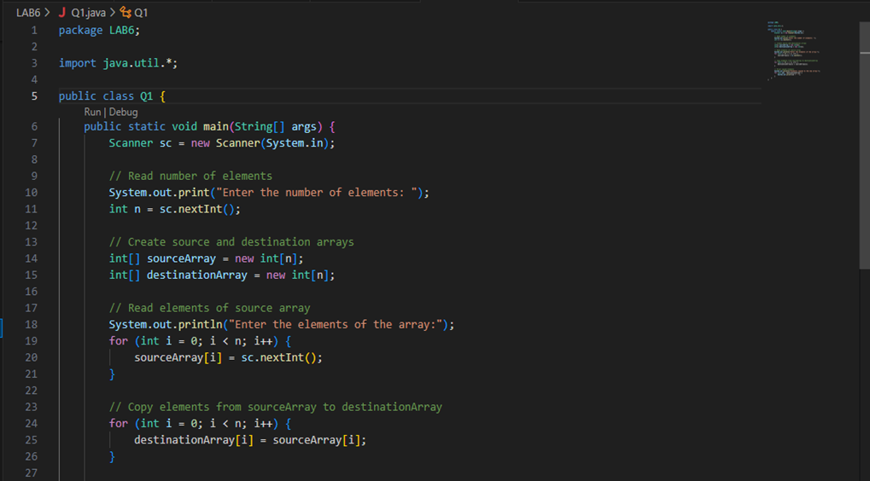

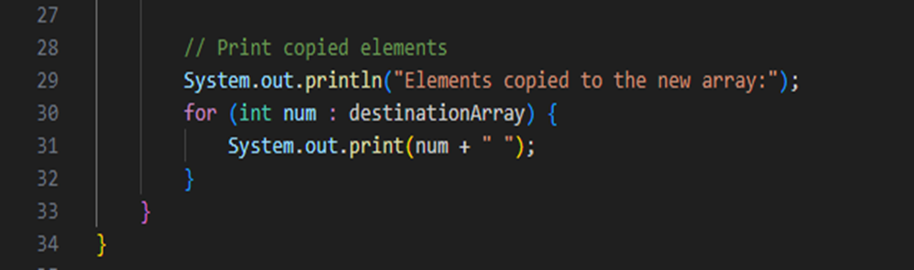

OUTPUT FOR QUES 1 –



2. Create a package p containing a class A with four methods, each having different access modifiers (e.g., public, protected, default, and private). Write another class B in a different package Q with a main() method. Demonstrate how to access the methods of class A from class B, considering the access modifiers.

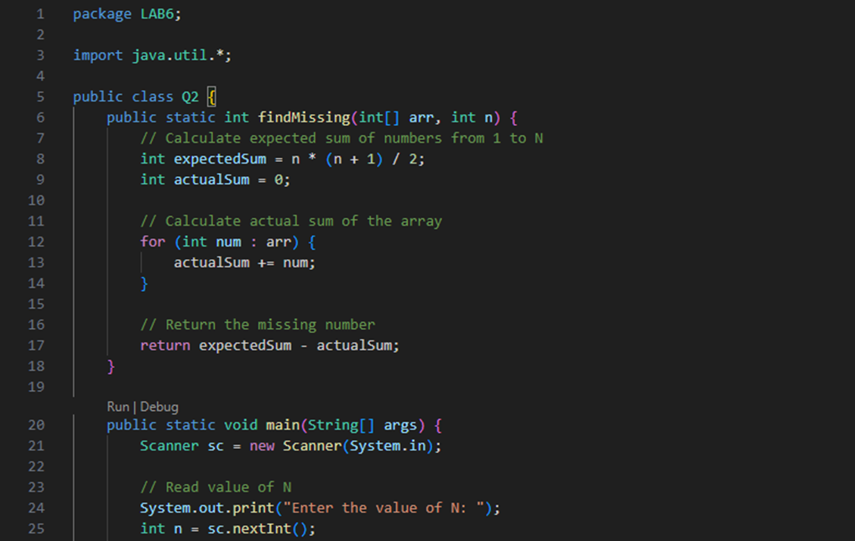

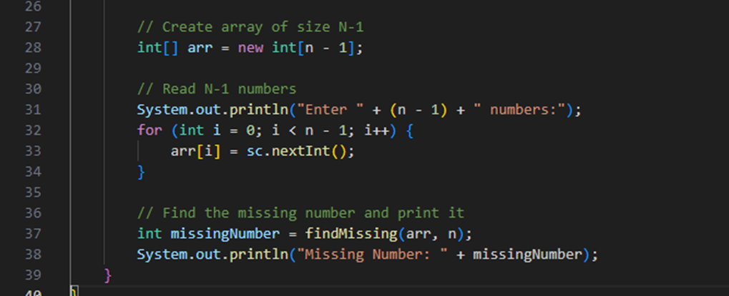  
 OUTPUT FOR QUES 2 –

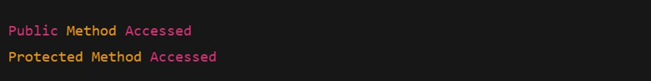

3. Write a Java program to demonstrate the use of the final keyword with a variable and a method. Create a class MathConstants with a final variable PI (value = 3.14159) and a final method displayPI() that prints the value of PI. Create another class Circle that extends MathConstants and includes a method calculateArea(double radius) to calculate and print the area of a circle using the formula: area = PI * radius * radius. In the main() method (in a separate class or Circle), test the calculateArea() method and observe the behavior when attempting to modify the PI variable or override the displayPI() method.

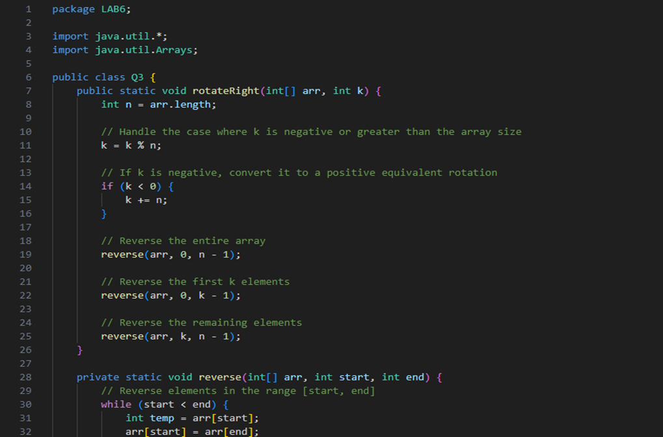

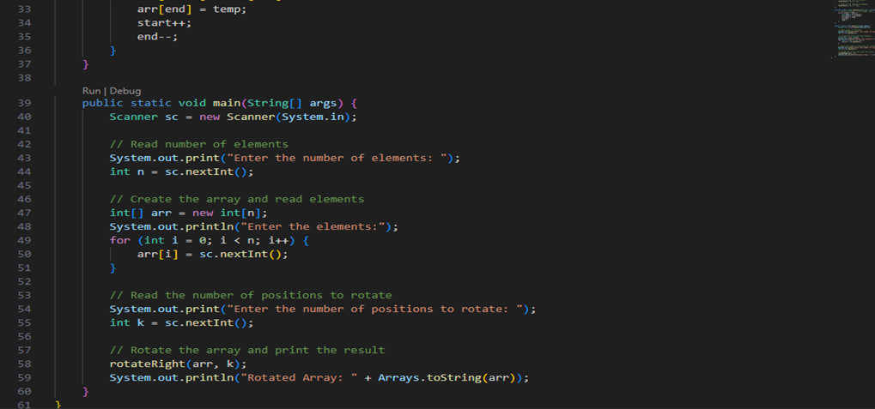  
 OUTPUT FOR QUES 3 –

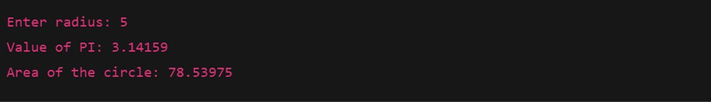

4. Write a Java program to demonstrate the use of the final keyword with a class. Create a final class Logger with a method logMessage(String message) that prints the message to the console. Attempt to create another class ExtendedLogger that extends the Logger class, and observe and explain the result. In the main() method (in a separate class), create an object of the Logger class and call the logMessage() method to print a sample message.

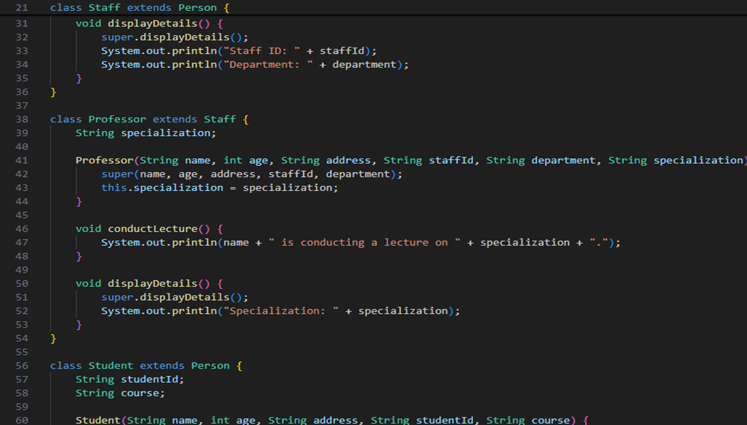

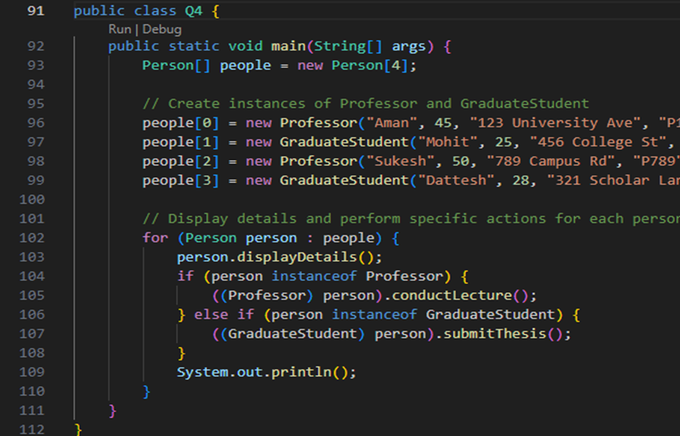

OUTPUT FOR QUES 4 ---  
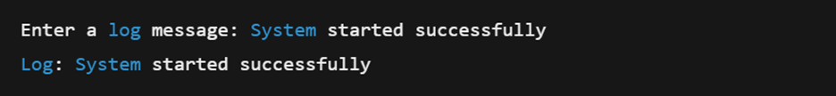

EXPERIMENT – 7

1. Write a Java program to create an abstract class Shape with an abstract method calculateArea(). Derive two classes Rectangle and Circle from Shape and override the calculateArea() method to calculate and print the area of a rectangle and a circle, respectively. Use the main() method to create objects of Rectangle and Circle and test their calculateArea() methods. 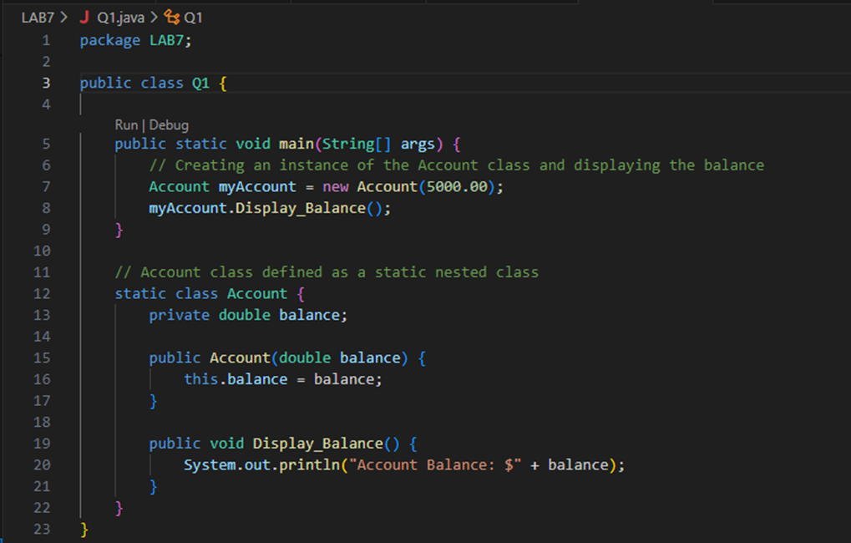

OUTPUT FOR QUES 1 –

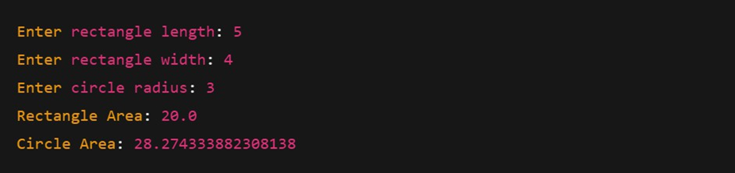

2. Write a Java program to create an abstract class Employee with abstract methods calculateSalary() and displayDetails(). Derive two classes Manager and Developer from Employee and implement the methods to calculate the salary (e.g., based on fixed salary or hourly wage) and display employee details (e.g., name, role, salary). In the main() method, create objects of Manager and Developer and test their functionality

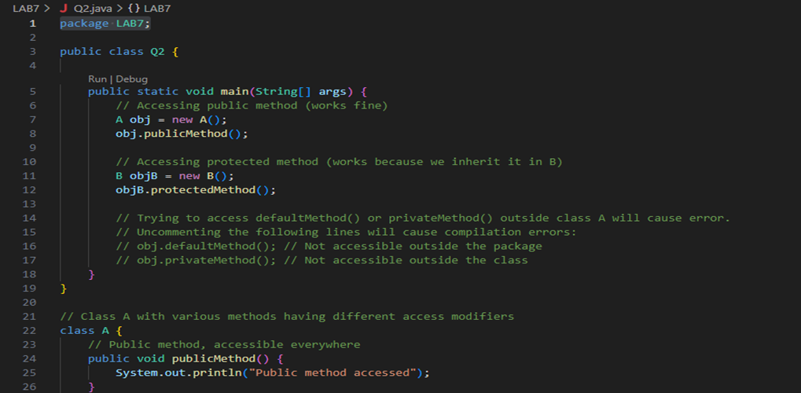

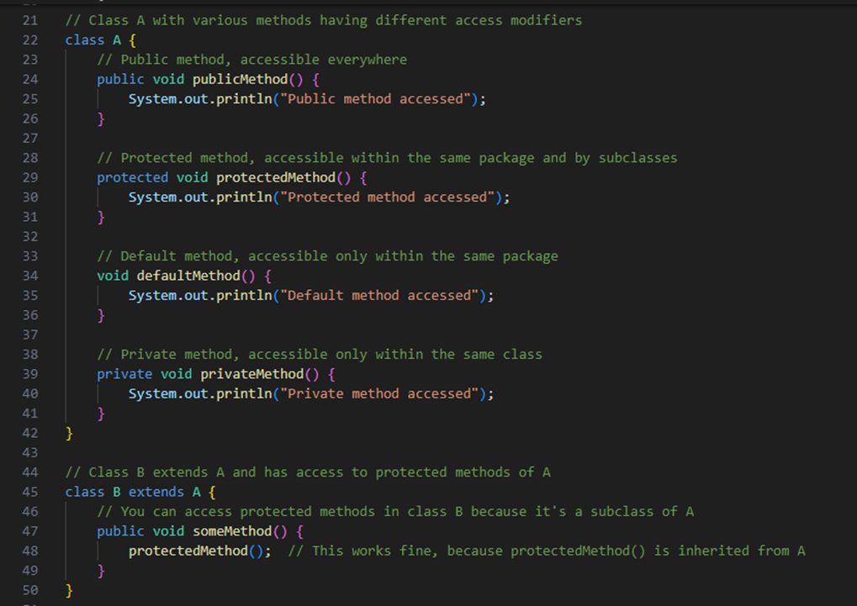

OUTPUT FOR QUES 2 -

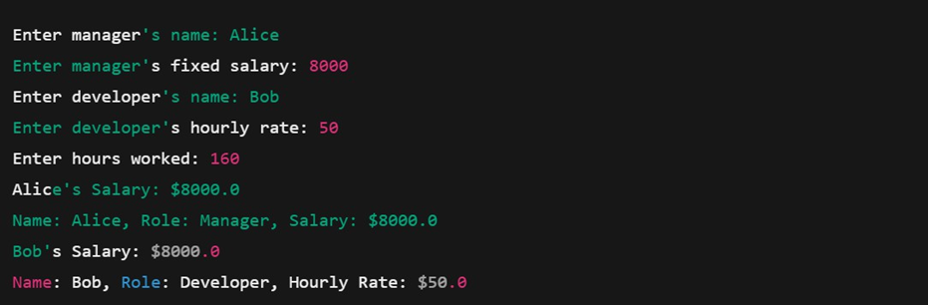

3. Write a Java program to create an interface Bank with methods deposit(double amount) and withdraw(double amount). Implement this interface in a class Account that overrides these methods to perform deposit and withdrawal operations on a balance variable. Create another class BankDemo with a main() method to test the functionality by depositing and withdrawing amounts and displaying the updated balance.

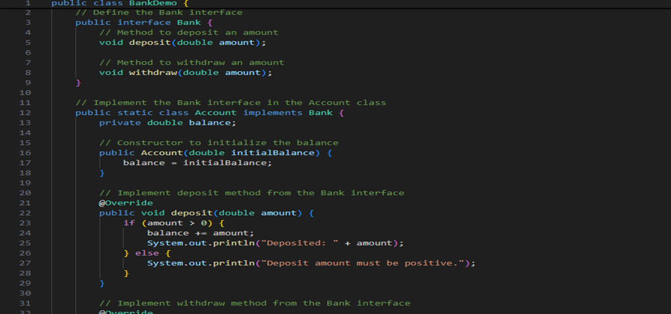

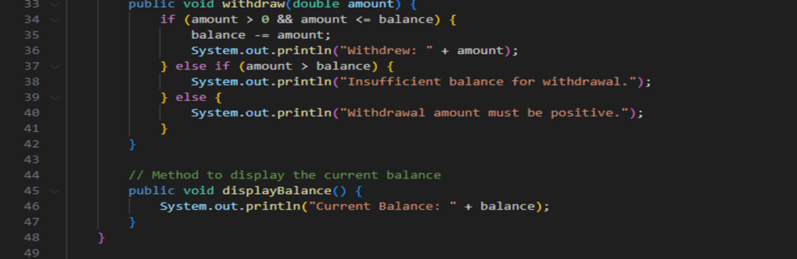

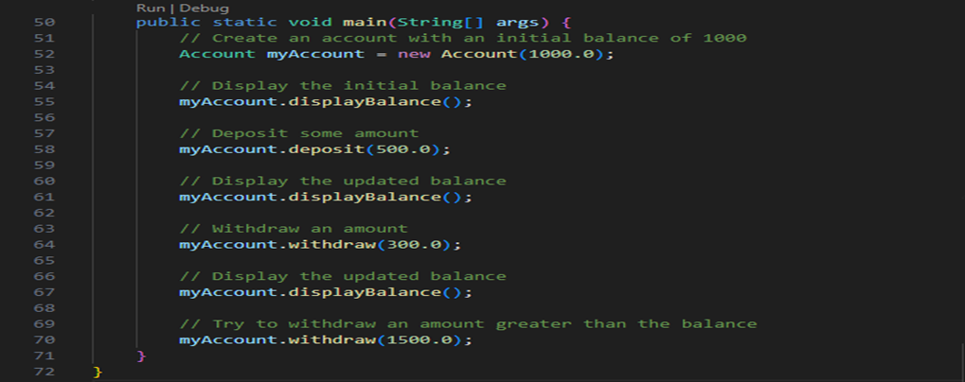

OUTPUT FOR QUES 3-  
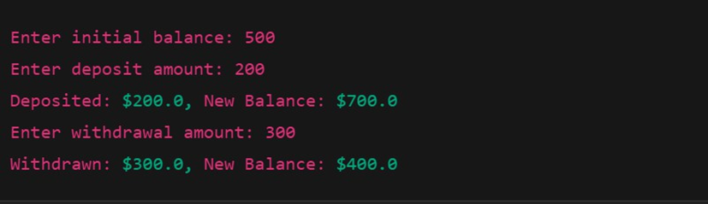

4. Write a Java program to create an interface Playable with methods play(), pause(), and stop(). Implement this interface in a class MusicPlayer that overrides these methods to print appropriate messages (e.g., "Music is playing," "Music is paused," "Music is stopped"). Create another class TestPlayer with a main() method to test the functionality by calling the play(), pause(), and stop() .

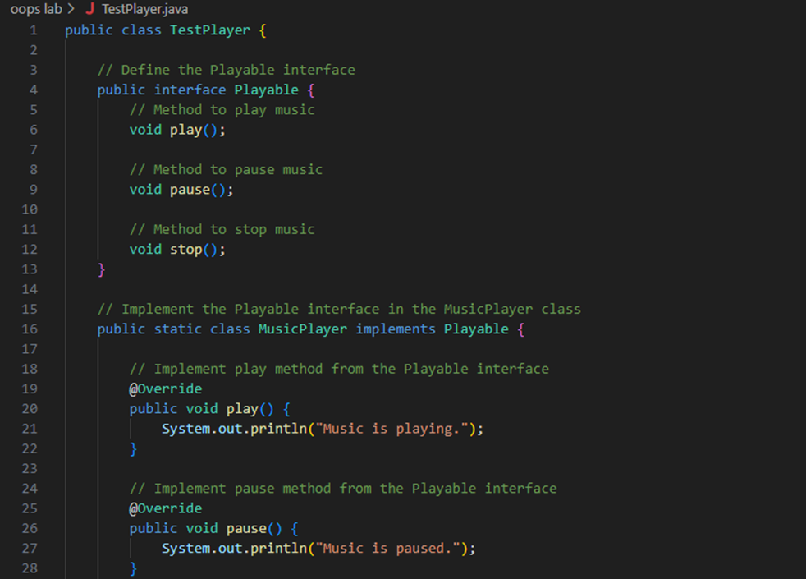

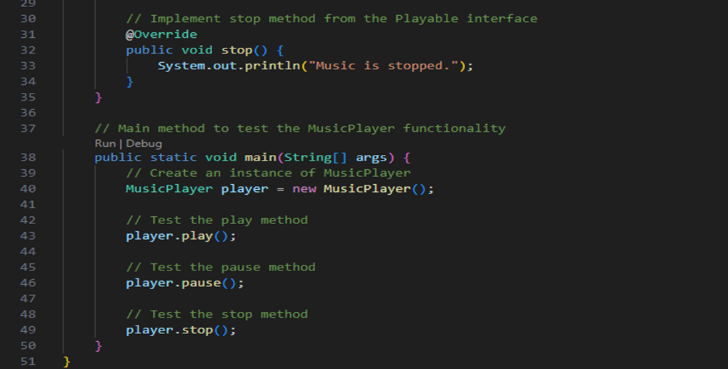

OUTPUT FOR QUES 4 –





EXPERIMENT 8

1.Create an outer class Library with a static nested class Book. The Book class should have attributes like title, author, and ISBN, and a method displayDetails() to print these details. In the main method, create an instance of the Book class and call displayDetails() to show the book information.

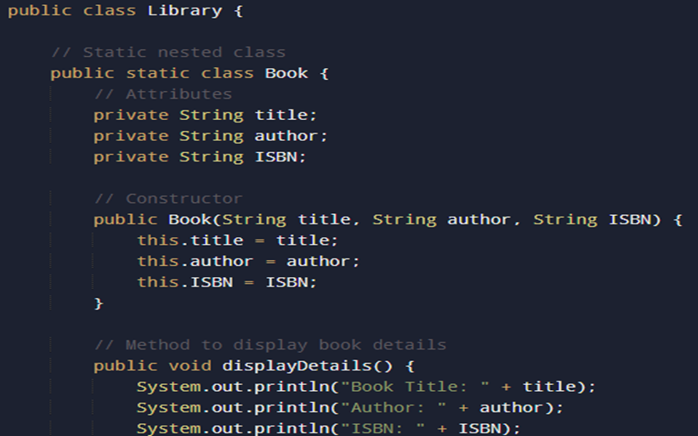

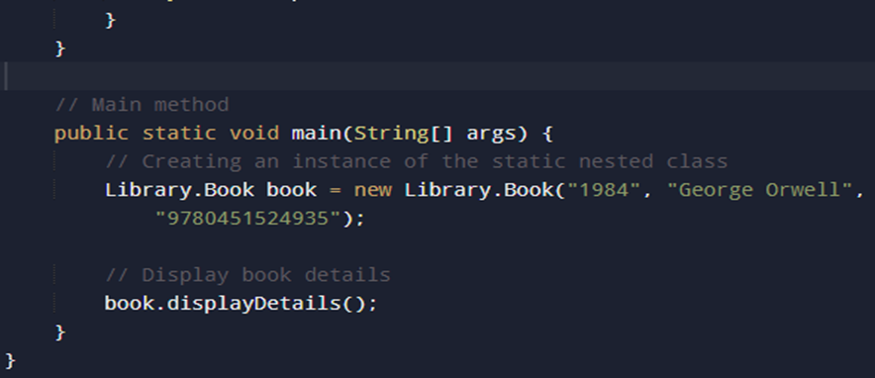

2.Create an outer class Car with an inner class Engine. The Engine class should have a method start() that prints "Engine started" and a method stop() that prints "Engine stopped". The Car class should have a method drive() that creates an instance of the Engine class and calls its start() and stop() methods

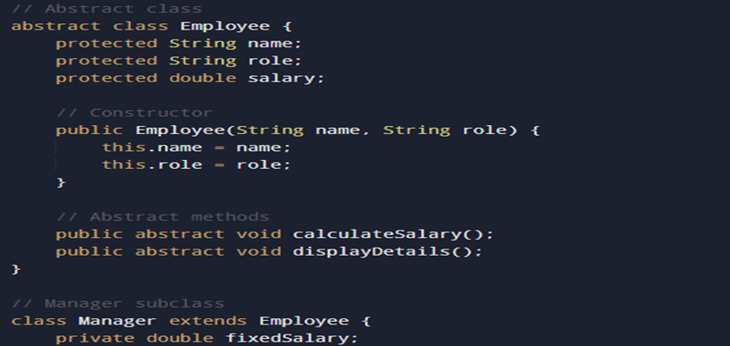

3.Write a Java program to create an interface Bank with methods deposit(double amount) and withdraw(double amount). Implement this interface in a class Account that overrides these methods to perform deposit and withdrawal operations on a balance variable. Create another class BankDemo with a main() method to test the functionality by depositing and withdrawing amounts and displaying the updated balance.

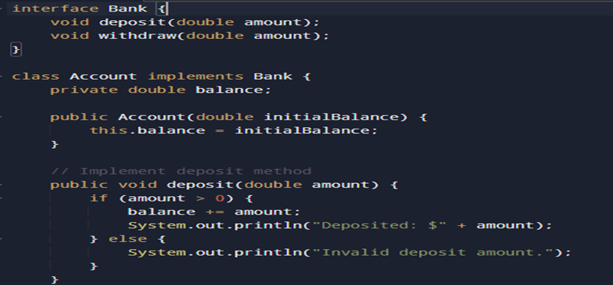

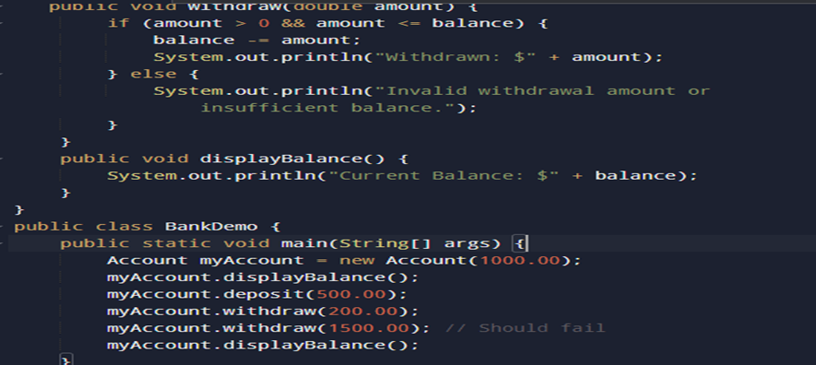

OUTPUT 1:

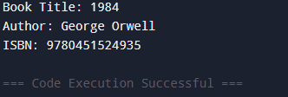

OUTPUT 2:

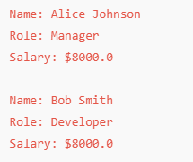

OUTPUT 3:

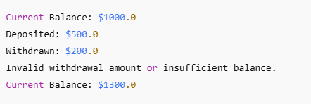

4.Create an interface EventHandler with a method handleEvent(). In the main method, demonstrate the use of: a. A local inner class inside a method registerEvent() that implements EventHandler and prints "Event handled by local inner class". b. An anonymous inner class that implements EventHandler and prints "Event handled by anonymous inner class".

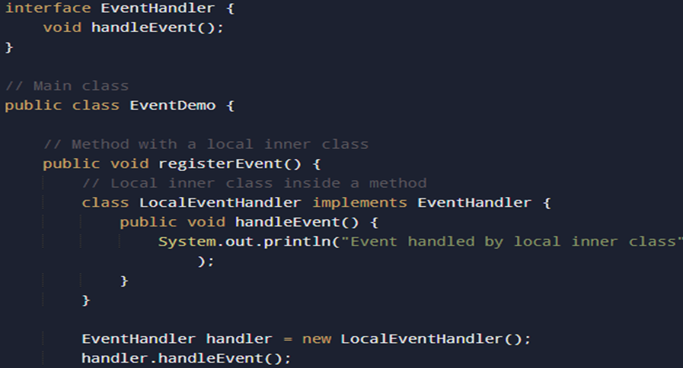

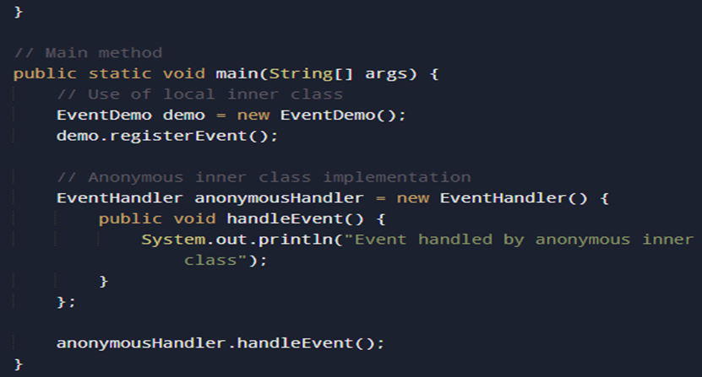

5.Write a Java program that creates an array of 5 integers and asks the user to enter an index to access the array element. Handle the ArrayIndexOutOfBoundsException if the user enters an invalid index. Use a try-catch block to catch the exception and display an appropriate error message. Use the finally block to print "Array access attempted."

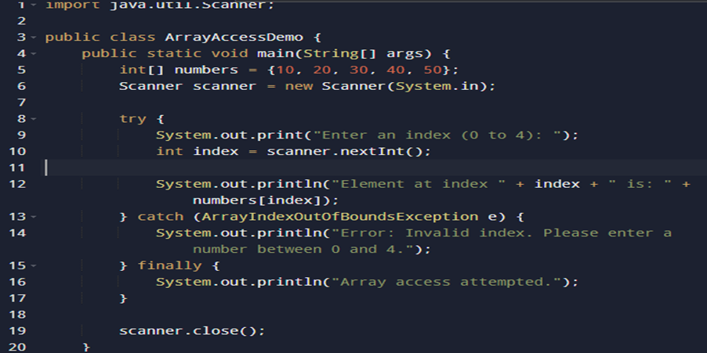

6.Write a Java program that takes user input for a student's name, roll number, and grade, and writes this information to a file named student.txt using **FileWriter**. Ensure the program appends the data to the file if it already exists. Handle any exceptions using try-catch and display an appropriate message if an error occurs.

*Sample File Content:*

Name: Aman, Roll Number: 120112, Grade: A

Name: Parul, Roll Number: 120131, Grade: B

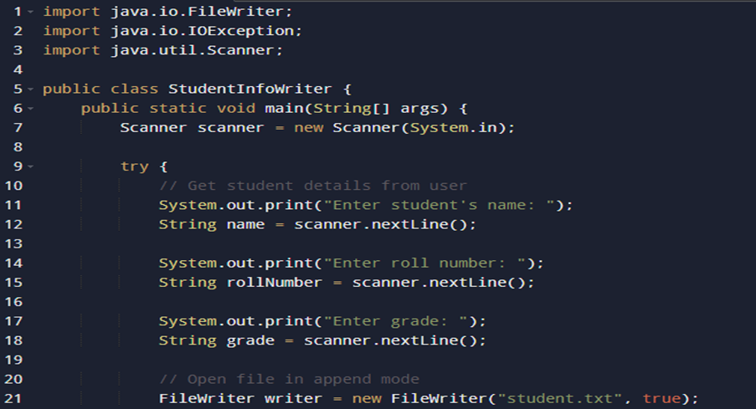

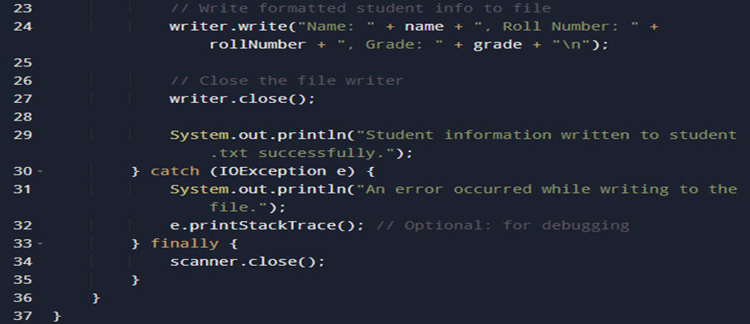

7.Write a Java program that reads the contents of a file named student.txt using **FileReader** and displays the data on the console. Handle FileNotFoundException if the file does not exist and display an appropriate error message. Use a try-catch block for exception handling

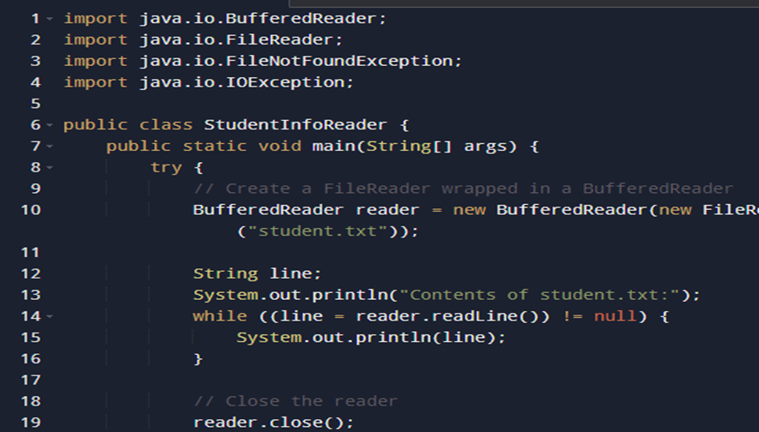

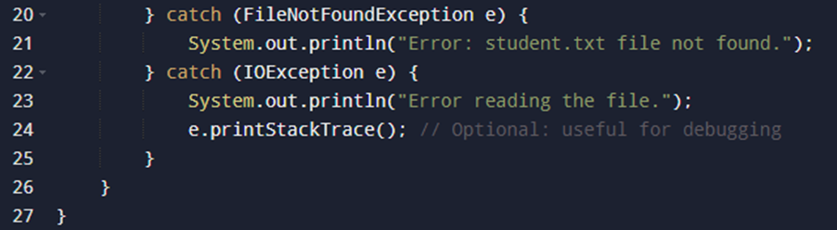

OUTPUT 5:

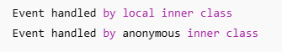

OUTPUT 6:

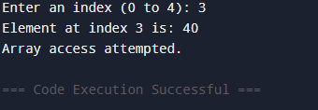

OUTPUT 7:

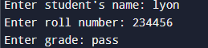

OUTPUT 8:

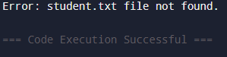

EXPERMINENT 9

1.Write a Java Swing program to create a Login Form using JTextField, JPasswordField, JButton, and JLabel. When the login button is clicked, validate if the username is "admin" and the password is "password".

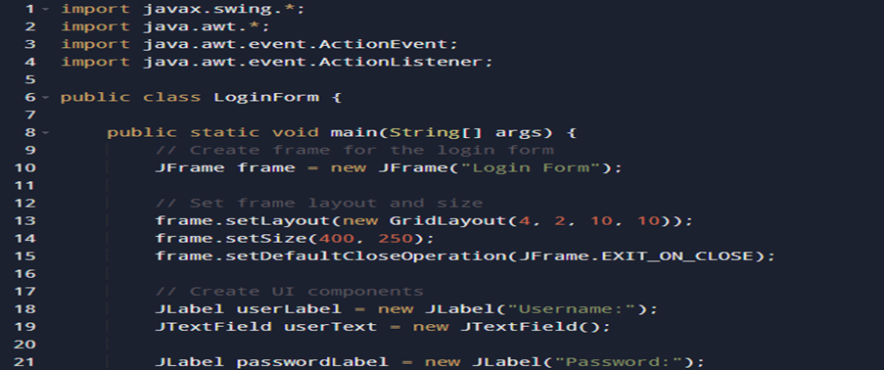

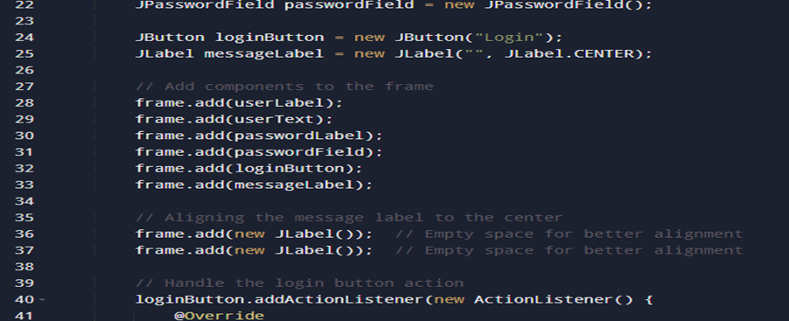

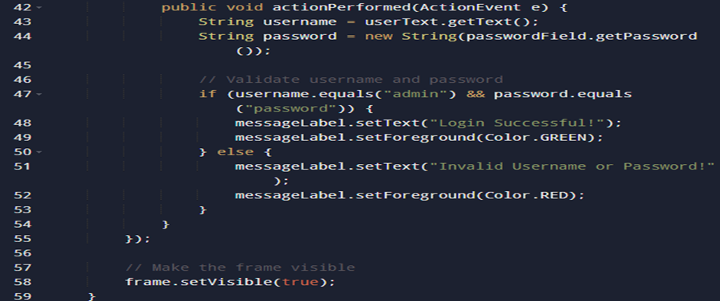

2. Design a simple calculator using Java Swing with buttons for digits (0-9), addition (+), subtraction (-), multiplication (*), and division (/). Implement event handling for button clicks and display the result in a JTextField.

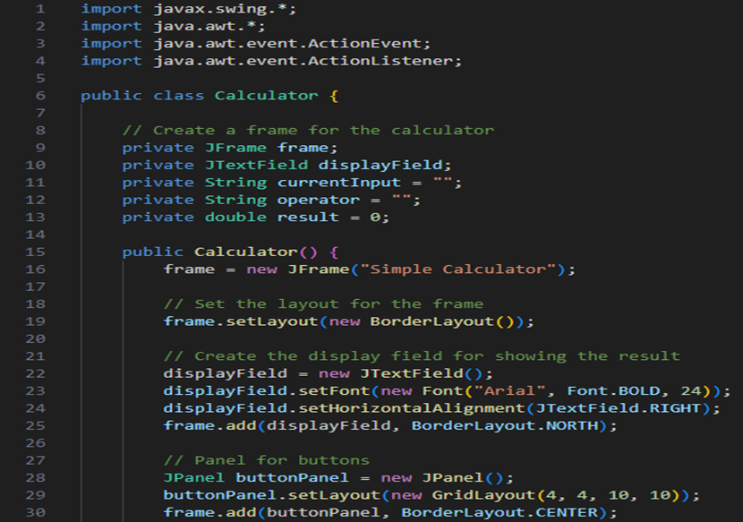

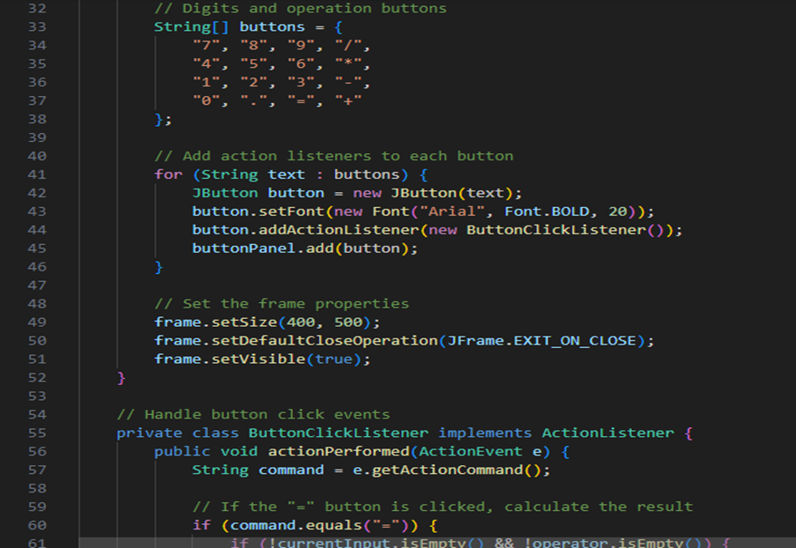

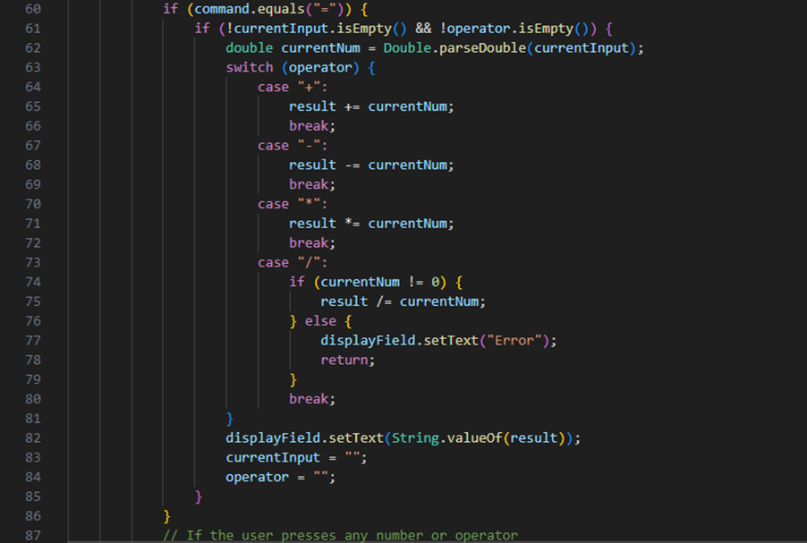

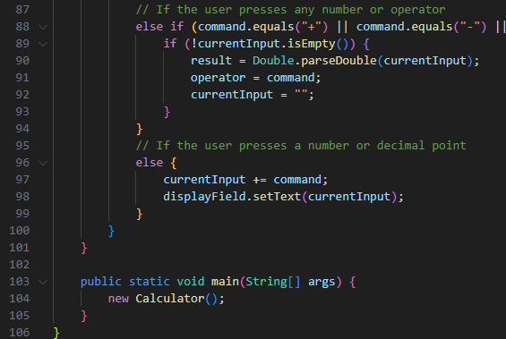

OUTPUT 1:

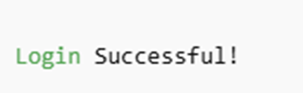

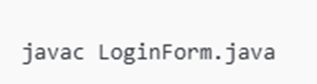

OUTPUT 2:

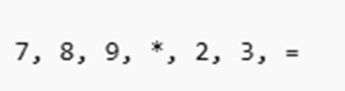



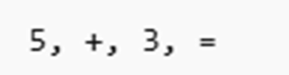



3.Write a Java Swing program to implement a To-Do List using JList. Provide:

a. A JTextField to enter tasks

b. An Add button to add tasks to the list

c. A Remove button to delete selected tasks

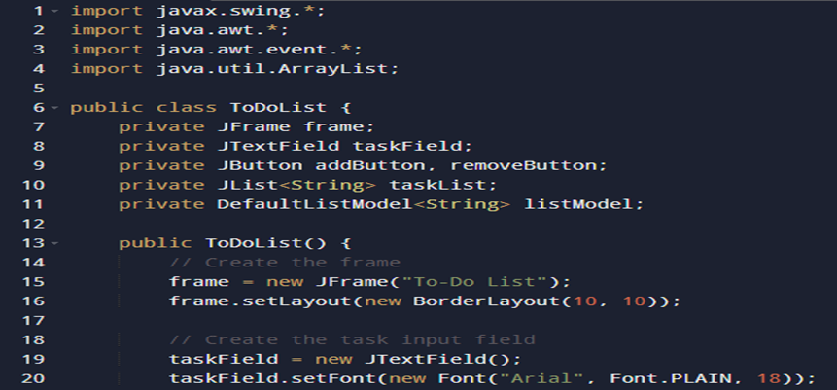

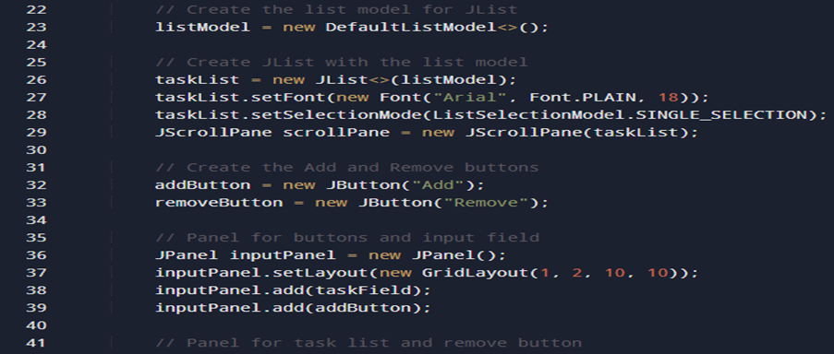

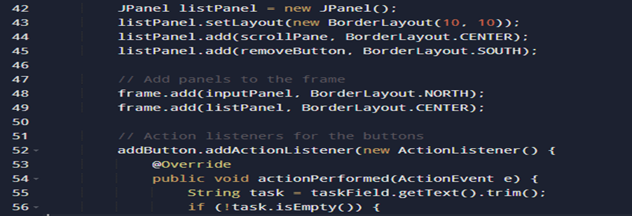

OUTPUT 3:

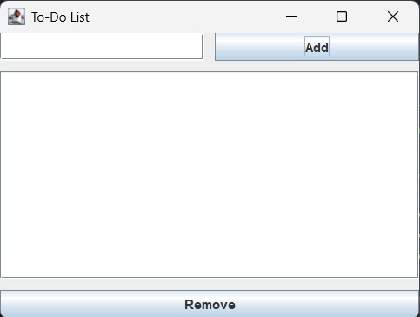

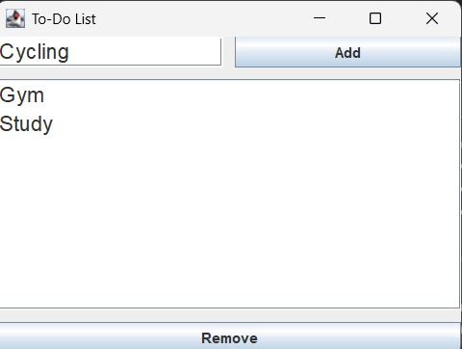

EXPERMINENT 10

1.Store a list of integers in an ArrayList<Integer> using autoboxing. Iterate through the list, unbox each value, and determine if it is a prime number, printing the results.

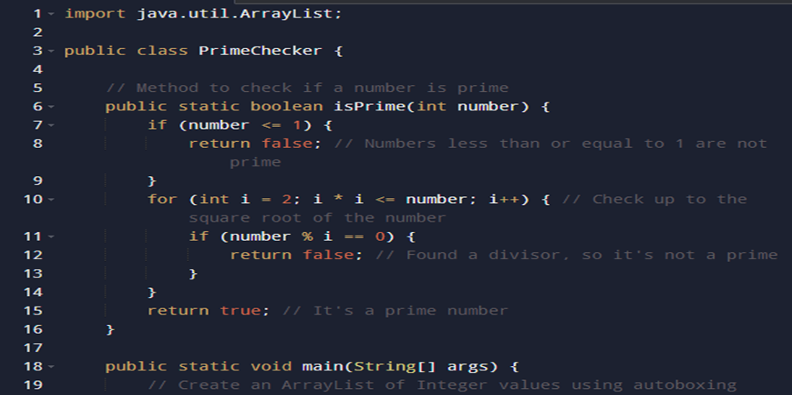

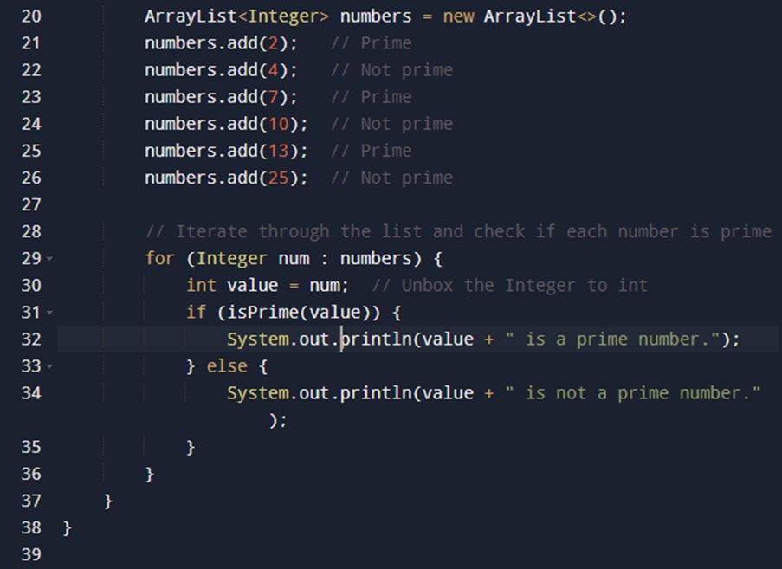

2. Create an ArrayList to store Employee objects with attributes like name, id, and salary. Add three employees, update one employee's salary, remove another by their id, and print the remaining employees.

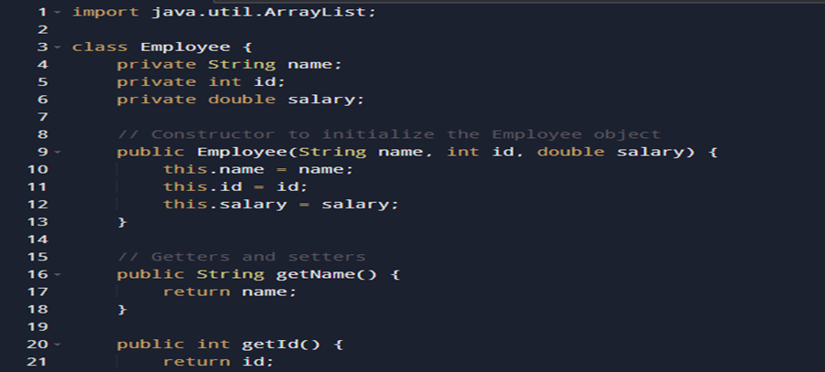

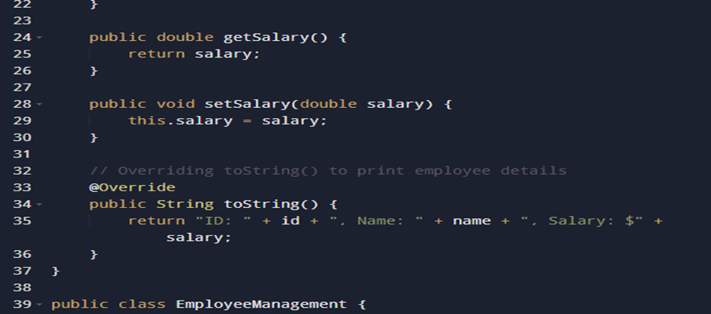

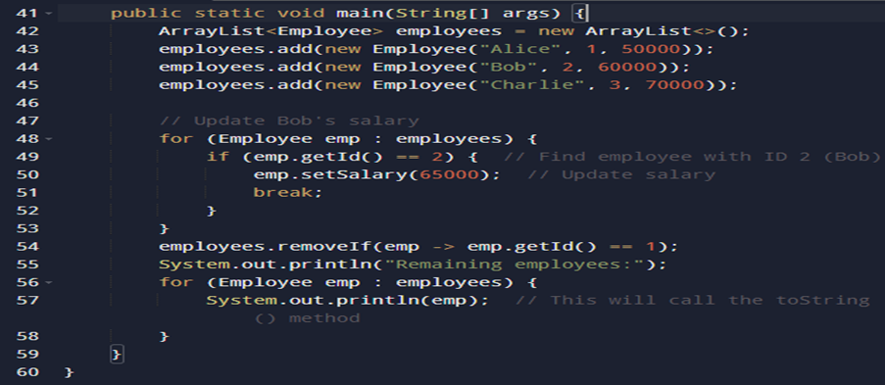

OUTPUT 1:

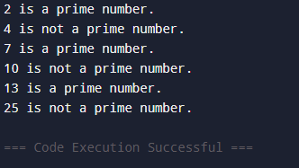

OUTPUT 2:

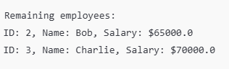

3.Use a HashMap to manage a product inventory where keys are productId (Integer) and values are quantity (Integer). Add three products, update the quantity of one product, remove another, and display the final inventory.

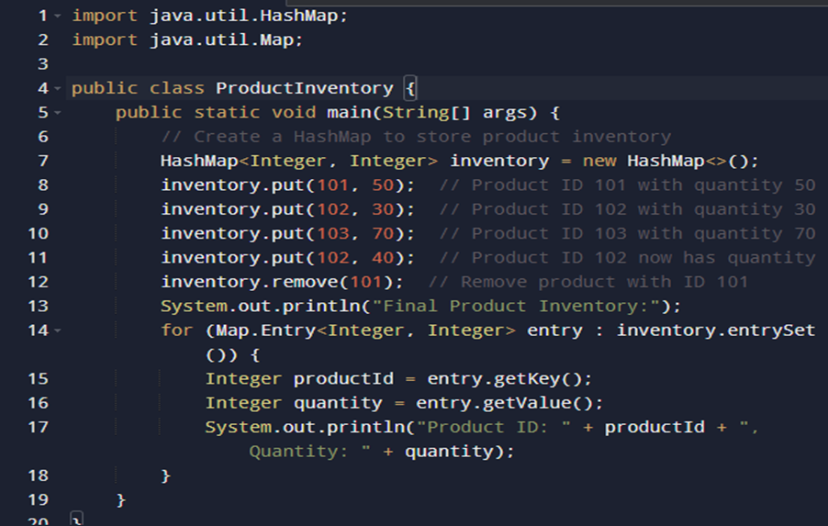

4. Given an array of names with duplicates (e.g., ["Aman", "Varchasv", "Divyansh", "Varchasv", ”Aman”]), store them in a HashSet to eliminate duplicates. Check if a specific name exists in the set and print the unique names.

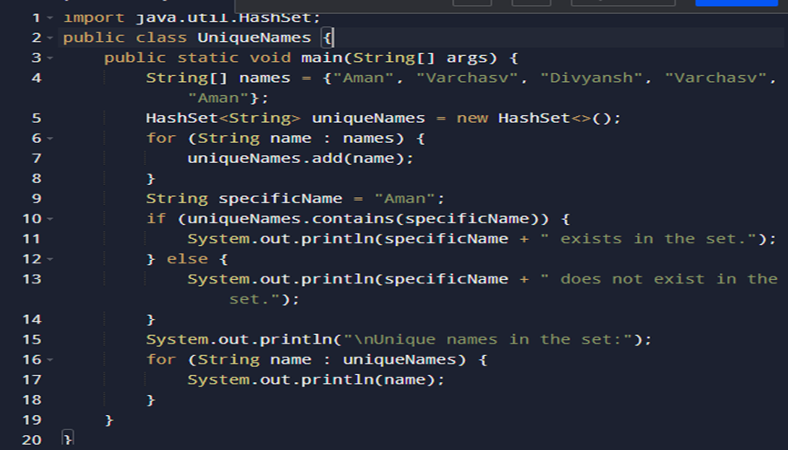

5. Given an ArrayList of integers (possibly with duplicates), find the sum of its unique values. [Hint: Convert it to HashSet]

Example:

Input: [3, 5, 3, 8, 2, 5]

Unique values: [3, 5, 8, 2]

Sum: 18

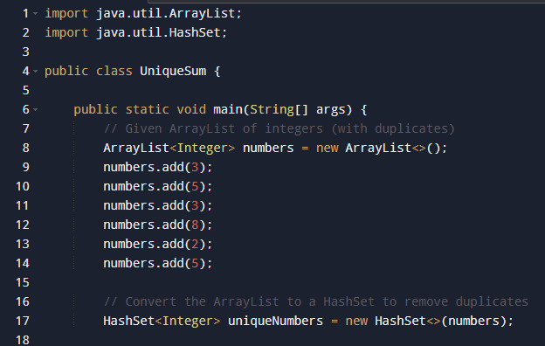

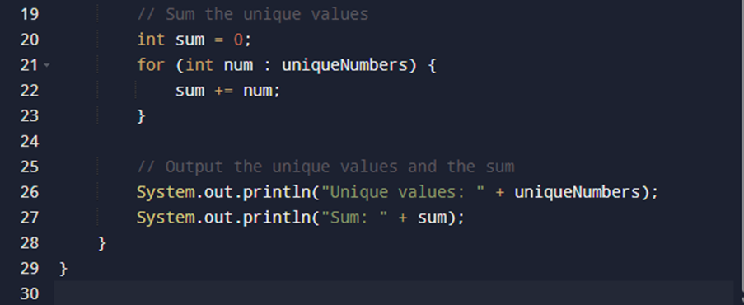

OUTPUT 3:

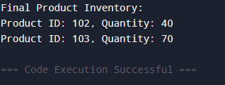

OUTPUT 4:

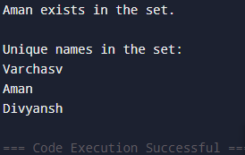

OUTPUT 5:

